# Report on Univariate Inflation Forecasting from March 2014 to November 2024 with Hyperparameter Tuning Approaches

**1. Introduction**

This report aims to analyze the univariate inflation data from March 2014 to November 2024 and forecast future inflation rates for the next 3 months. Four different approaches have been employed to improve the accuracy and reliability of the forecasting model, specifically focusing on hyperparameter tuning techniques. The methods used are:

1. **Without Hyperparameter Tuning**
2. **With Hyperparameter Tuning using Grid Search CV**
3. **With Hyperparameter Tuning using Random Search CV**
4. **With Hyperparameter Tuning using Optuna**

The forecasted inflation values from each method are compared to determine the most effective approach for this dataset.

### ****2. Data Overview****

The dataset consists of univariate time series data on inflation, spanning from March 2014 to November 2024.

### ****3. Methodology****

#### **3.1. Without Hyperparameter Tuning**

In the first approach, the forecasting model was trained and tested without applying any hyperparameter tuning. The default parameters of the chosen model were used to establish a baseline for comparison with other approaches.

#### **3.2. With Hyperparameter Tuning using Grid Search CV**

Grid Search Cross-Validation (GridSearchCV) was applied to the univariate forecasting model to search for the best combination of hyperparameters.

#### **3.3. With Hyperparameter Tuning using Random Search CV**

Random Search Cross-Validation (RandomSearchCV) was used to explore hyperparameter values in a randomized fashion, which can be more efficient than GridSearchCV, especially when the hyperparameter space is large.

#### **3.4. With Hyperparameter Tuning using Optuna**

Optuna, an advanced hyperparameter optimization framework, was employed for this approach. Optuna uses efficient sampling techniques to optimize hyperparameters and search the space more effectively.

* **Optuna Setup**: The search space for each hyperparameter was defined, and an optimization objective was set. Optuna then explored the space to find the best hyperparameter configuration.

**4. Results and Comparison**

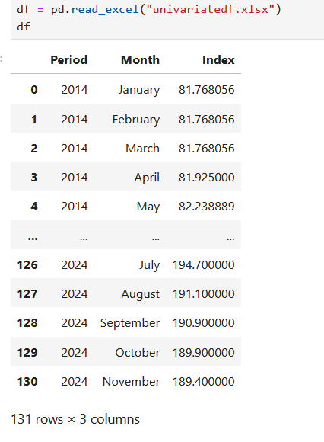The forecasting results from the four approaches were evaluated using the following metrics:

* **Mean Absolute Error (MAE)**
* **Mean Squared Error (MSE)**
* **Root Mean Squared Error (RMSE)**
* **Mean Absolute Percentage Error (MAPE)**
* **R-Square**

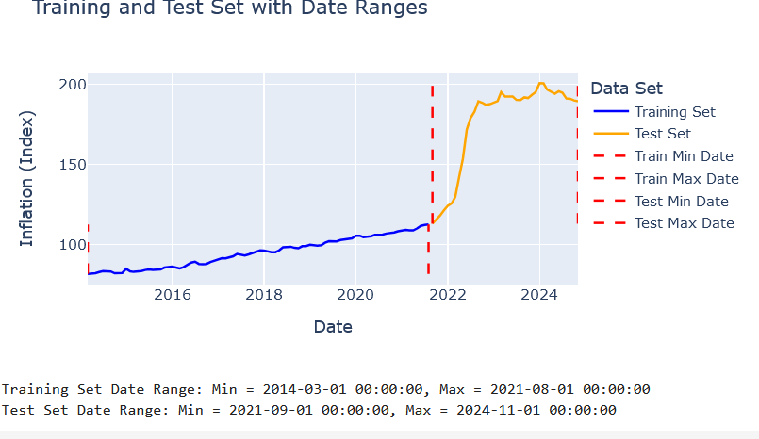

Number of Lags to be considered as X test.

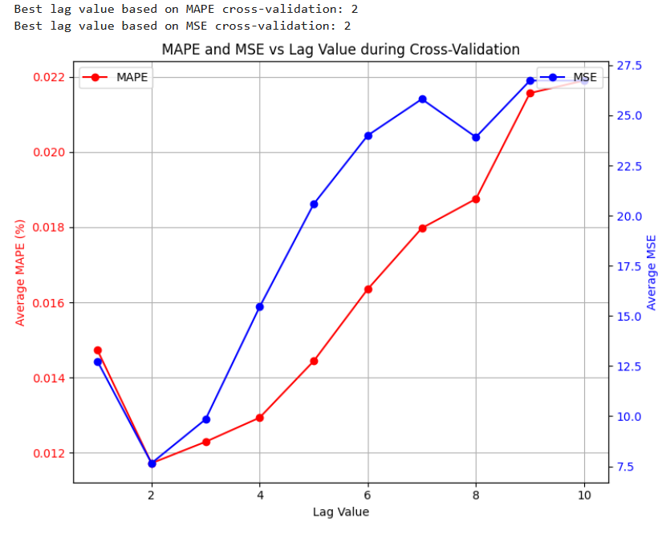

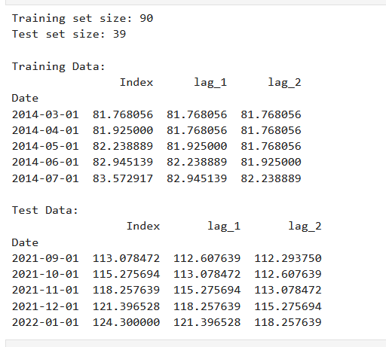

**Case 1: Without Hyperparameter Tuning for Full univariate Data Set**

**Evaluation.**

|  |  |  |  |  |  |  |  |
| --- | --- | --- | --- | --- | --- | --- | --- |
| **Random Forest Evaluation:** | **XGBoost Evaluation:** | **Gradient Boosting Evaluation:** | **Support Vector Machine Evaluation:** | **Multi-layer Perceptron Evaluation:** | **ANN Evaluation:** | **Convolutional Neural Network (CNN) Evaluation:** | **LSTM Evaluation:** |
| **RMSE: 69.6824**  **MSE: 4855.6347**  **MAE: 63.8118**  **MAPE: 34.10%**  **R-squared: -5.1959** | **RMSE: 69.4487**  **MSE: 4823.1153**  **MAE: 63.5565**  **MAPE: 33.95%**  **R-squared: -5.1544** | **RMSE: 69.5268**  **MSE: 4833.9754**  **MAE: 63.6418**  **MAPE: 34.00%**  **R-squared: -5.1682** | **RMSE: 84.8092**  **MSE: 7192.6059**  **MAE: 79.3212**  **MAPE: 42.95%**  **R-squared: -8.1779** | **RMSE: 6.0471**  **MSE: 36.5679**  **MAE: 3.8727**  **MAPE: 2.31%**  **R-squared: 0.9533** | **RMSE: 6.8762**  **MSE: 47.2826**  **MAE: 4.3472**  **MAPE: 2.6061%**  **R-squared: 0.9396** | **RMSE: 6.1913**  **MSE: 38.3325**  **MAE: 3.9204**  **MAPE: 2.35%**  **R-squared: 0.9511** | **RMSE: 6.1931**  **MSE: 38.3546**  **MAE: 4.9687**  **MAPE: 2.82%**  **R-squared: 0.9511** |

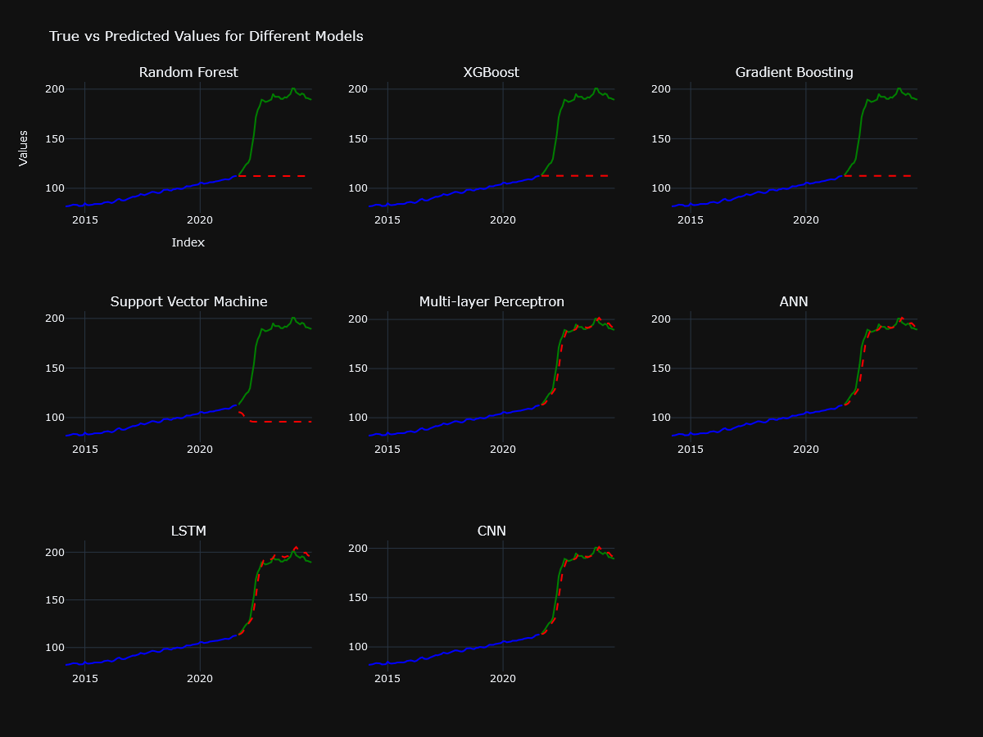

3 Months Ahead Forecasting

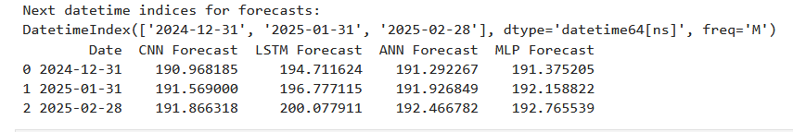

6 Months Ahead Forecast

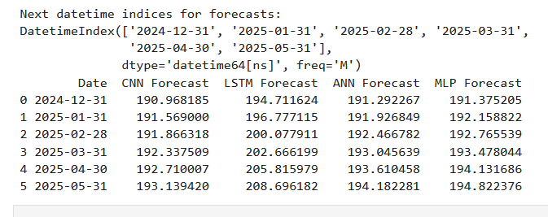

Case 2: **Hyperparameter Tuning using RandomSearchCV for Full univariate Data Set**

**Evaluation.**

|  |  |  |  |  |  |
| --- | --- | --- | --- | --- | --- |
| **Random Forest Evaluation:** | **XGBoost Evaluation:** | **Gradient Boosting Evaluation:** | **Support Vector Machine Evaluation:** | **Multi-layer Perceptron Evaluation:** | **ANN Evaluation:** |
| **RMSE: 69.8199**  **MSE: 4874.8191**  **MAE: 63.9619**  **MAPE: 34.19%**  **R-squared: -5.2203** | **RMSE: 69.9555**  **MSE: 4893.7744**  **MAE: 64.1099**  **MAPE: 34.27%**  **R-squared: -5.2445** | **RMSE: 69.6440**  **MSE: 4850.2836**  **MAE: 63.7698**  **MAPE: 34.07%**  **R-squared: -5.1890** | **RMSE: 4.1434**  **MSE: 17.1675**  **MAE: 2.6972**  **MAPE: 1.61%**  **R-squared: 0.9781** | **RMSE: 4.2070**  **MSE: 17.6991**  **MAE: 2.7383**  **MAPE: 1.63%**  **R-squared: 0.9774** | **RMSE: 7.0459**  **MSE: 49.645139**  **MAE: 4.4761676**  **MAPE: 2.679348%**  **R-squared: 0.936652** |

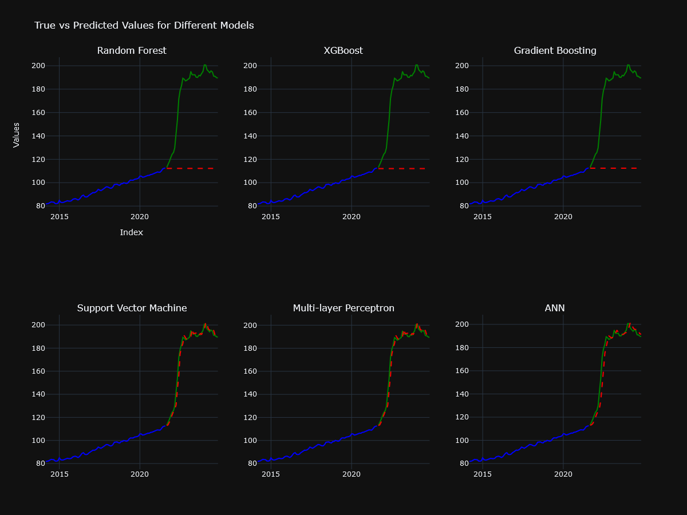

6 Months ahead forecasting

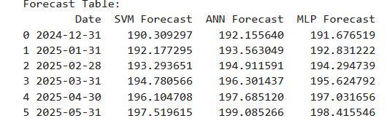

Case 3: **Hyperparameter Tuning using GridSearchCV for Full univariate Data Set**

**Evaluation.**

|  |  |  |  |  |
| --- | --- | --- | --- | --- |
| **Random Forest Evaluation:** | **XGBoost Evaluation:** | **Gradient Boosting Evaluation:** | **Support Vector Machine Evaluation:** | **Multi-layer Perceptron Evaluation:** |
| **RMSE: 69.7169**  **MSE: 4860.4433**  **MAE: 63.8494**  **MAPE: 34.12%**  **R-squared: -5.2020** | **RMSE: 69.4487**  **MSE: 4823.1153**  **MAE: 63.5565**  **MAPE: 33.95%**  **R-squared: -5.1544** | **RMSE: 69.4530**  **MSE: 4823.7129**  **MAE: 63.5612**  **MAPE: 33.95%**  **R-squared: -5.1551** | **RMSE: 3.9211**  **MSE: 15.3751**  **MAE: 2.5592**  **MAPE: 1.52%**  **R-squared: 0.9804** | **RMSE: 4.1162**  **MSE: 16.9435**  **MAE: 2.6917**  **MAPE: 1.60%**  **R-squared: 0.9784** |

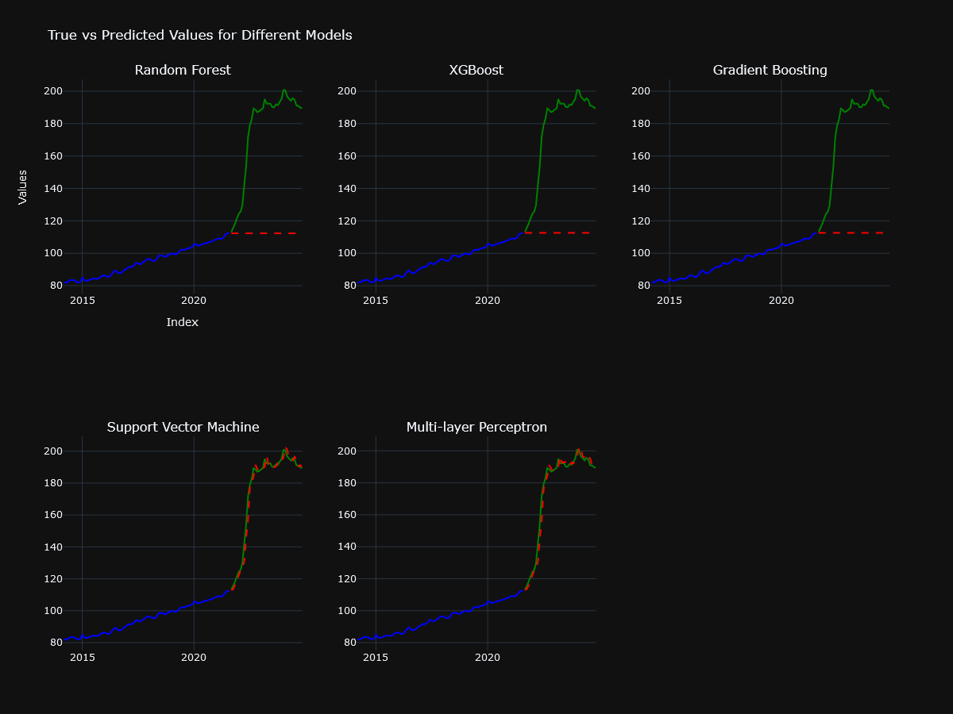

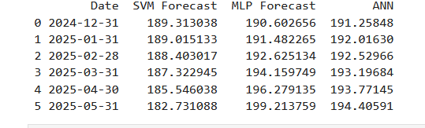

Case 4: **Hyperparameter Tuning using Optuna for Full univariate Data Set**

**Evaluation.**